Task 10: Firewall Configuration & Testing
1.Learn firewall concepts
What is a Firewall?
- A firewall is a security system that monitors and controls network traffic.
- It allows or blocks traffic based on predefined security rules.
- Firewalls act as a barrier between trusted and untrusted networks.
Purpose of a Firewall
- Prevent unauthorized access
- Protect systems from attacks
- Control network traffic
- Reduce attack surface
Types of Firewalls
- Host-based firewall – Installed on individual systems (UFW, Windows Firewall)
- Network-based firewall – Protects an entire network
- Hardware firewall – Physical device
- Software firewall – Runs on an OS
Firewall Rule Components
- IP Address – Source or destination
- Port Number – Service port (e.g., 22, 80)
- Protocol – TCP or UDP
- Action – Allow or Deny
Inbound vs Outbound Traffic
- Inbound traffic – Incoming connections to your system
- Outbound traffic – Connections initiated by your system
- Firewalls can control both
Default Firewall Policies
- Default Deny – Block all traffic unless allowed (recommended)
- Default Allow – Allow all traffic unless blocked

Stateful vs Stateless Firewall
- Stateful firewall
  - Tracks active connections
  - More secure
- Stateless firewall
  - Checks packets individually
  - Faster but less secure
Why Firewalls are Important
- Prevent port scanning attacks
- Block malicious IP addresses
- Protect exposed services (SSH, HTTP)
- Enforce network security policies

2.Configure rules.
Check Firewall Status
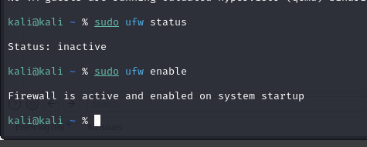
Set Default Policies
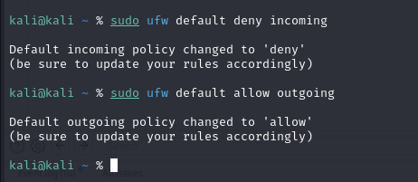

3.Allow/deny ports
Allow Essential Services
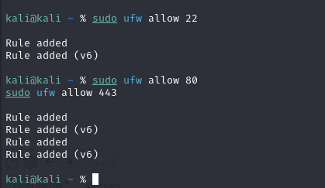
Deny Unnecessary Ports
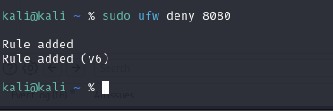
Configure IP-Based Rules
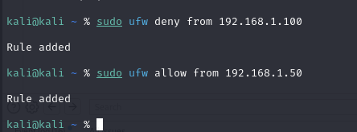
View Configured Rules
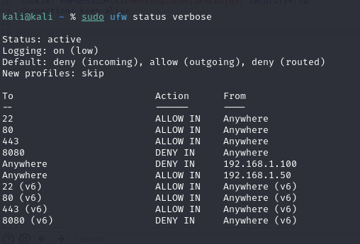

4.Test connectivity
Test allowed ports
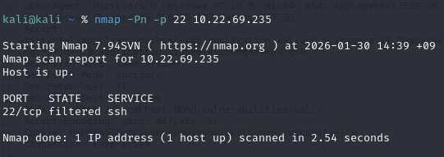
Test other allowed ports correctly
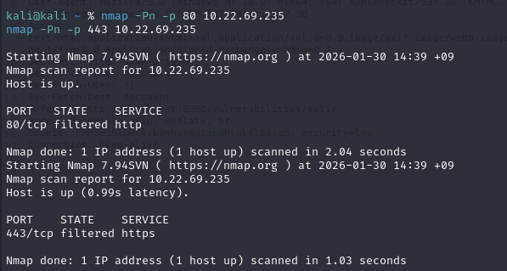
Test blocked port
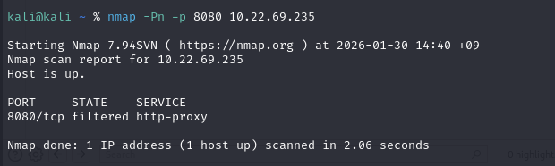

5.Observe logs
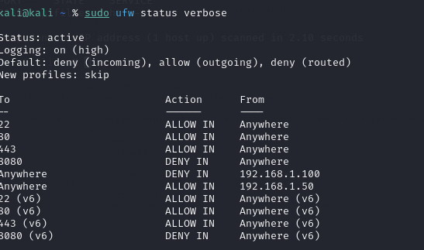
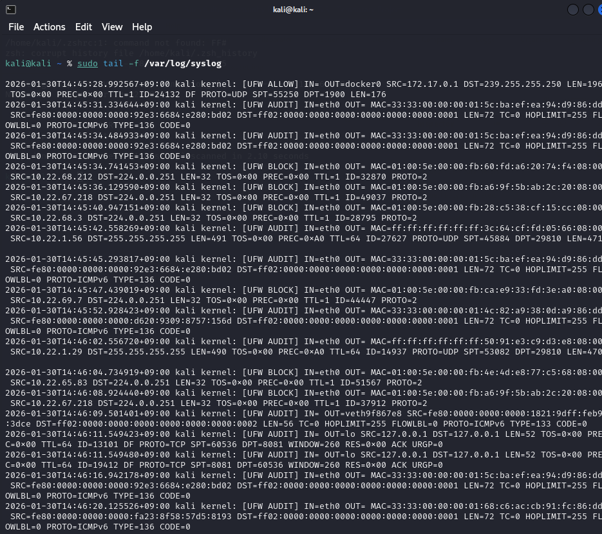
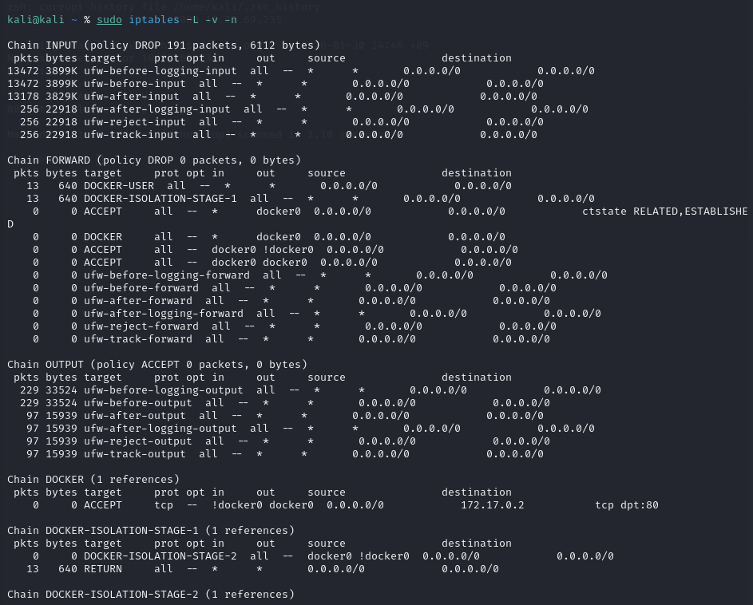

6.Block malicious IP.
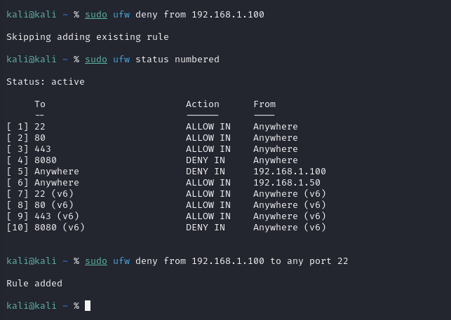
7.Document rules
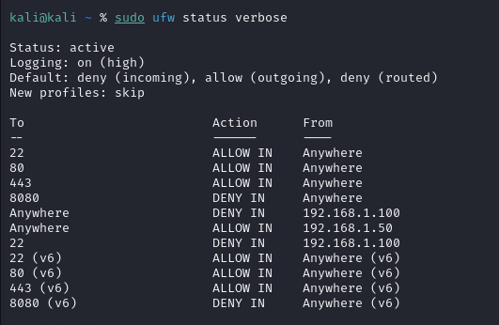
8.Explain impact
Security Impact
- Unauthorized access to the system is prevented
- Only essential services (SSH, HTTP, HTTPS) remain accessible
- Unnecessary and risky ports are blocked
- Known malicious IP addresses are denied access
- System exposure to attacks is reduced
Network Impact
- Legitimate traffic continues without interruption
- Blocked ports appear filtered or closed during scans
- ICMP blocking increases stealth against reconnaissance
- Network traffic is controlled and monitored
Administrative Impact
- Clear visibility of allowed and blocked services
- Easier troubleshooting and auditing
- Improved control over network access policies

Conclusion
This task demonstrated the configuration and testing of firewall rules to control network traffic effectively. By allowing essential services, blocking unnecessary ports, and denying malicious IP addresses, the firewall significantly reduced the system’s attack surface. Connectivity testing and rule documentation confirmed that the firewall was functioning as intended, highlighting the importance of firewalls in maintaining system and network security.

